Original: [UCI Machine Learning Repository: Human Activity Recognition Using Smartphones Data Set](http://archive.ics.uci.edu/ml/datasets/Human+Activity+Recognition+Using+Smartphones)

[A public domain dataset for human activity recognition using smartphones (upc.edu)](https://upcommons.upc.edu/handle/2117/20897)

Paper:

[Smart Phone Based Data Mining for Human Activity Recognition - ScienceDirect](https://www.sciencedirect.com/science/article/pii/S1877050915000320)

* information theory based feature ranking algorithm and classifiers based on random forests, ensemble learning and lazy learning
* good short explanation of different classifiers

[[PDF] Energy Efficient Smartphone-Based Activity Recognition using Fixed-Point Arithmetic | Semantic Scholar](https://www.semanticscholar.org/paper/Energy-Efficient-Smartphone-Based-Activity-using-Anguita-Ghio/ed2cd4d99795a83a429d733e5cae5fab2dfb868f)

* a modified multiclass Support Vector Machine (SVM) learning algorithm
* signal processing is described in more detail
* Multi class classification with regularization -> usage of sigmoid function
* 89% precision reached

[C:/Users/Luca/Desktop/Dropbox/Paper/2012/NIPS - Machine Learning Approaches to Mobile Context Awareness/v4/nips2012.dvi (core.ac.uk)](https://core.ac.uk/download/pdf/41773853.pdf)

* This method adapts the standard Support Vector Machine (SVM) and exploits fixed-point arithmetic
* Precision 89%

<https://www.sciencedirect.com/science/article/pii/S2096232019300046>

* 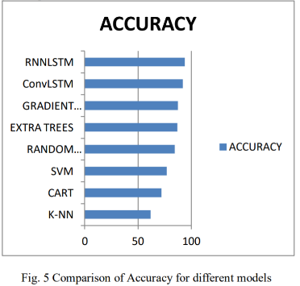least square model averaging perspective

<https://www.ijrte.org/wp-content/uploads/papers/v8i1/A1385058119.pdf>

* Convolutional Neural Network with Long-Short Term Memory [ConvLSTM] and Recurrent Neural Network with Long-Short Term Memory [RNNLSTM] using only the raw data

Tutorials:

The first one being my favourite – great explanation of the data set, its structure and how to make sense of it

[How to Model Human Activity From Smartphone Data (machinelearningmastery.com)](https://machinelearningmastery.com/how-to-model-human-activity-from-smartphone-data/)

[Human Activity Recognition Using Smartphone Data | Project | Learnbay - YouTube](https://www.youtube.com/watch?v=yEN-1iJNBmw) #

[Human Activity Recognition Using Smartphones Sensor Data | by Xiaoshan Sun | Medium](https://medium.com/@xiaoshansun/human-activity-recognition-using-smartphones-sensor-data-fd1af142cc81)

<https://github.com/MadhavShashi/Human-Activity-Recognition-Using-Smartphones-Sensor-DataSet>